**Information**

|  |  |  |
| --- | --- | --- |
| **CRIM ID** | **Title** | **Workstream** |
| C0460 | PM Actions Pre-posting fix | Finance, Service |

**Revision History**

|  |  |  |  |
| --- | --- | --- | --- |
| **Revision** | **Date** | **By** | **Remarks** |
| 0.1 | 11/01/2021 | Jennifer Anderson | Base spec |
| 1.0 | 12/1/2021 | Jennifer Anderson | Updates from Erika Sukevic and Matt Colley |
|  |  |  |  |
|  |  |  |  |

# CRIM Narrative

During solution build testing, it was found that there is an issue with PM actions in that the Pre-postings are not automatically populated from the service contract, which is not consistent with other functionality, such as work tasks.

A custom event is required for PM actions on a WO to automatically pull through the pre-postings from the Service contract (line first, then check header), in the same way that the Work Task currently work.

1. PM Action generates a Work Order

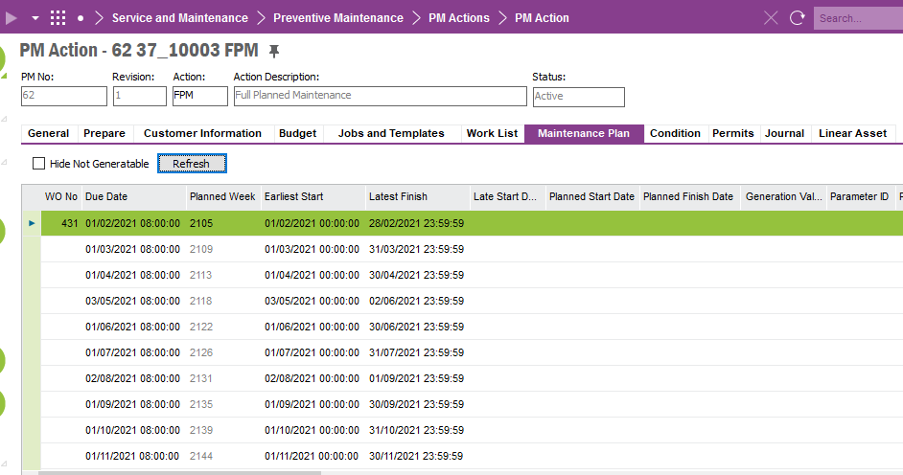

1. Service Contract Line – pull Pre-Posting from here first as a default

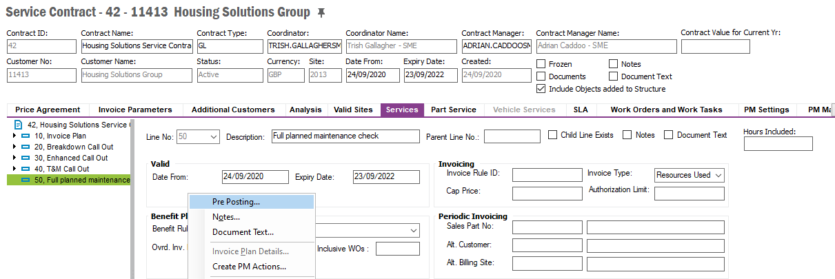

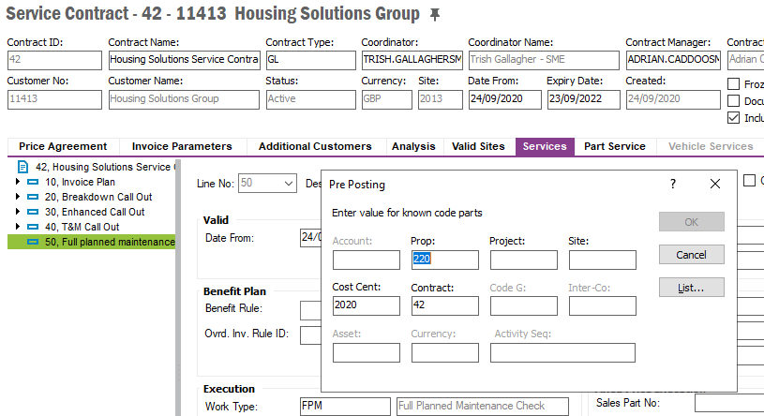

1. If there is no Pre-posting setup on the line, then use the Pre-posting on the Service Contract Header

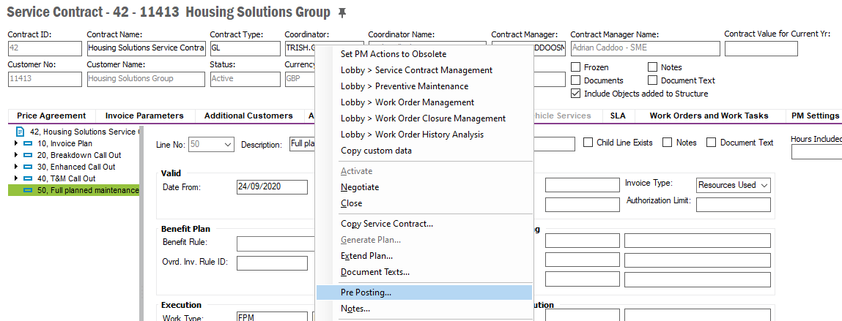

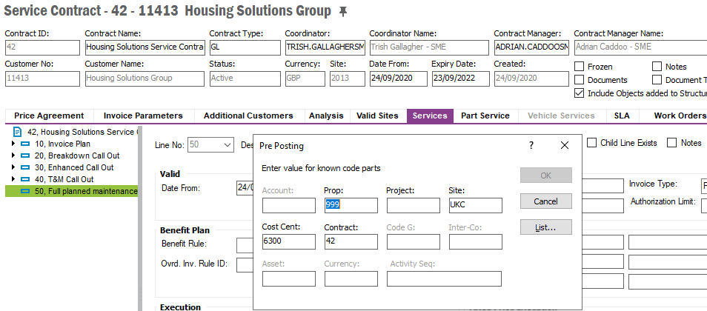

The Pre-Posting values should then default through on the Work Order for the PM Action below:

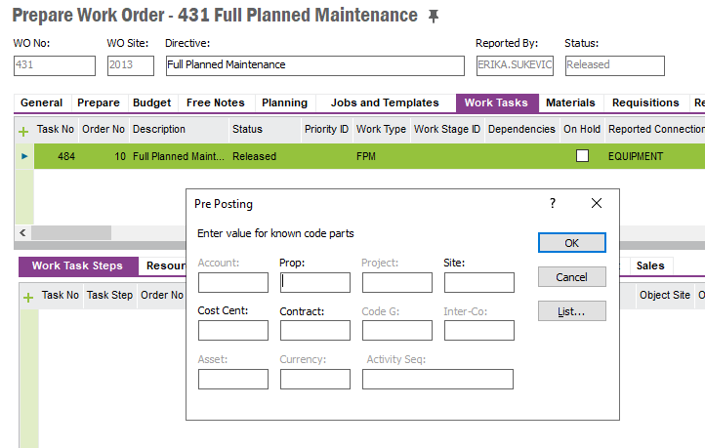

# Technical Proposal

# Technical Solution

## Technical Process

***********************************************

## Report Components

********************************************

## Known Dependencies

*\*\*\*\* Guidance Notes – Remove prior to submission \*\*\*\**

***********************************************

# Deployment Instructions

*\*\*\*\* Guidance Notes – Remove prior to submission \*\*\*\**

***********************************************

# Developer Test Proposal

*\*\*\*\* Guidance Notes – Remove prior to submission \*\*\*\**

* *Tests recommended by the developer to be included in UAT*

*e.g.*

| **Test ID** | **Recommended Test** |
| --- | --- |
| 1 | Test the boundaries of all parameters |
| 2 |  |
| 3 |  |
| 4 |  |
| 5 |  |
| 6 |  |
| 7 |  |

***********************************************

# User Acceptance Tests

***********************************************

# Delivery Notes

1. Package - **EA_Finance_Services**
2. Permission granted **– IFS_ALL**
3. Custom Events - **FETCH_PRE_POSTING_SCL** and **UPDATE_PRE_POSTING_TASK**

**UPDATE_PRE_POSTING_TASK Event**

Note: Update_Pre_Posting_Task Events posts a background job. To check the status of the background job, query for ‘To get pre-posting information based on Service Contract Header Pre-posting - C0460’ as the description.

**FETCH_PRE_POSTING_SCL** **Event**